QAOA for Joint Store Location and Inventory Optimization
Lakshanasri G¹, Mohanapriya S¹,Monica M¹
Department of Artificial Intelligence and Machine Learning
Manakula Vinayagar Institute of Technology
Puducherry, India

Mrs. Rajasundari T
Assistant Professor, Department of Artificial Intelligence and Machine Learning
Manakula Vinayagar Institute of Technology, Puducherry, India
Abstract. In India, the rapid growth of quick-commerce has resulted in approximately 5,000+ dark stores operating across more than 400 cities, highlighting the growing scale and complexity of hyper local delivery networks. As this network continues to expand, efficiently deciding where dark stores should be located, which customer areas should be assigned to each store, and how much inventory each store should maintain has become a critical challenge. Treating these decisions independently can lead to inefficient store placement, unbalanced inventory, increased delivery distances, higher operational costs, and under utilization of storage capacity.This project proposes an integrated optimization framework based on Quadratic Unconstrained Binary Optimization (QUBO) and the Quantum Approximate Optimization Algorithm (QAOA) to jointly optimize dark-store location selection, customer-to-store assignment, and inventory allocation. The proposed model considers practical constraints such as budget, storage capacity, customer demand, inventory requirements, and service coverage, enabling these interdependent decisions to be represented within a unified optimization problem.The proposed approach aims to provide quick-commerce companies with a more coordinated and data-driven method for planning their hyper local operations. In real-world applications, the solution can help reduce infrastructure and inventory costs, improve storage utilization, minimize delivery distances, reduce stock out risks, and enhance service efficiency. Thus, the project demonstrates the potential of quantum optimization techniques to support more cost-efficient, scalable, and responsive quick-commerce networks in India.
Keywords: Quick Commerce, Facility Location Optimization, Inventory Allocation, QUBO (Quadratic Undefined Binary Constraints), QAOA (Quantum Approximate Optimization Algorithm) , Quantum Optimization.
- Introduction
Quick commerce has disrupted the Indian household grocery and daily essentials market. Industry estimates put the number of dark stores at over five thousand, across over four hundred cities. These are small warehouses, insulated from the public, dedicated only to picking and packing orders. Their success lies in proximity to demand, as a customer who is expecting the order to be delivered within ten minutes, will not be reassured that it will take fifteen minutes. Studies on the rise of Indian hyper local delivery highlight the rapid scaling and dependence on a dense network of nearby fulfillment points [7].
The challenge is balancing three planning choices. A company has to decide where to open up candidate locations, which customer zones each store will serve, and which products, and how much of each, every store should hold. Opening more stores shortens delivery trips but raises rent and fixed cost. Stocking more products raises availability but fills the shelves and increases holding cost. Planners often anchor their location choice and then inventory choice, and a good site can end up with a poor stock mix, and a well stocked store can end up serving the wrong neighbourhood. Work on micro-fulfilment network planning in quick commerce reports that placement and service speed are closely linked [8], and work on dark store portfolios highlights the fragility of a network when these choices are made without regard to disruption [2].
Quantum optimization suggests a new way to approach such a problem. Facility location and allocation problems can be expressed as quadratic binary models, and the Quantum Approximate Optimization Algorithm (QAOA) is designed to search such a model with a shallow parameterized circuit tuned by a classical optimizer. Recent studies have expressed facility location and load balancing as QUBO problems and solved them with QAOA [1], and QAOA has also been applied to vehicle routing [5], [10]. A broad mapping study of quantum and quantum-inspired methods in operations research confirms that logistics is one of the most active application areas, while also noting that much of it is still at a proof-of-concept stage [3].
The objective of this work is to build and test one integrated model, that selects dark-store locations, assigns customer zones to open stores and fixes SKU-level stocking, while respecting budget, capacity, demand and delivery-time constraints. The model is solved with QAOA and compared to an exact MILP solution.
The contributions of this paper are as follows. First, we provide a joint QUBO formulation, in which siting, assignment and stocking share one set of binary variables. Second, we describe the penalty design, including the slack variables for budget and capacity limits. Third, we map the model to an Using Hamiltonian and run it through a QAOA workflow connected to a web-based planning tool. Fourth, we compare QAOA with a MILP baseline using measures of interest to a planner, namely feasibility, cost gap and service level.
  - Research Gap
Existing quantum studies tend to address one aspect of the problem. Facility location work typically does not factor in product-level stock, and inventory work typically assumes the store network is already established. Few studies bring the two together, and even fewer apply road-network delivery time as the coverage measure for a hyper local setting. This paper addresses that combination.
- Literature Review
The use of QAOA for inventory applications has been explored in several recent studies. Sinha (2026) formulated a multi-warehouse problem as a QUBO, solved it via QAOA in Qiskit and compared the result to a classical PuLP model on a small synthetic network of thirty items across five locations. The study observes that fixed penalty bounds make the search easy to fall into local minima when constraints are not balanced. A pilot by Tata Elxsi (2025) performed QAOA directly on IBM quantum hardware to select critical automotive spare parts. Due to gate fidelity limitations, the pilot could only select five parts out of thirty. Ullah et al. (2024) addressed the warehouse capacity and lead-time limits together in a multi-variable QAOA model, but observed that adding soft slack terms for several products inflates the number of variables quadratically. Nishimura et al. (2025) mapped the multi-item warehouse rack positioning to a QUBO and solved the problem with a hybrid quantum-classical solver, but the circuits remained at one or two layers due to noisy gates.
Facility location has seen a similarly high attention. Vinci et al. (2025) proposed a compact QAOA with unbalanced penalisation and tested it on OR-Library facility location benchmarks. Accuracy dropped sharply on larger instances once hardware-calibrated noise was introduced. Ganz et al. (2024) compared gate-based QAOA with quantum annealing on an uncapacitated facility location benchmark, but they did not explore multi-product or multi-period inventory control. Wang et al. (2023) designed a variational algorithm that keeps the search within the feasible space for uncapacitated facility location. The ansatz is highly specialized, which makes it difficult to adapt to inventory settings spanning several periods. The work of Moncayo-Martínez and He [1] write facility location and load-balancing as QUBO problems and solve them with QAOA, and it is the closest formulation to ours. Classical studies on facility location have also shifted towards uncertainty, with learning-augmented mechanisms that use demand predictions to improve placement [4], and towards integrated models that combine facility location with order-allocation across two supply chain levels [9].
A second group of studies embeds quantum methods within broader logistics pipelines. Vanderbist et al. (2026) used an alternating hybrid QAOA on simulated maritime shipping networks and found that classical parameter tuning becomes costly when the circuit reaches three layers or more. Afrasiabi et al. (2026) combined QAOA, VQE and quantum annealing on industrial logistics and cross-docking data, and reported that the effort spent on hardware error mitigation grows rapidly with problem size. Li (2026) used a hybrid classical-quantum spin Hamiltonian on multichannel warehouse fulfillment data and showed that high penalty factors can produce solutions that are not physically feasible. Merali et al. (2025) explored cloud-based hybrid QAOA platforms for supply disruptions in small and medium enterprises, where the communication delay between edge optimizer and remote quantum back ends becomes a bottleneck. Zalando Engineering (2025) described how deep demand forecasting could be joined to quantum-informed network paths for SKU-level distribution, but the work remains at the framework stage without full quantum execution. Bhattacharyya et al. (2022) mapped multi-node allocation to an Ising Hamiltonian and solved the problem with QAOA via the Qiskit interface, but performance dropped once the supply nodes passed single digits.
Several studies provide context on methods and on the application domain. Fitzek et al. [5] and Azad et al. [10] applied QAOA to vehicle routing and showed that constrained routing can be encoded and solved with shallow circuits on small instances. Pellow-Jarman et al. [6] looked into how the choice of classical optimizer and the ansatz depth affect QAOA performance on noisy devices, which is directly relevant to how we set the depth in our experiments. Gomes et al. [3] and Tokar (2026) give the survey perspective, mapping quantum and quantum-inspired work in operations research and logistics. Tokar's review is qualitative and does not report on gate-level execution metrics. Hedayatnia et al. (2023) combined uncertainty theory with quantum-inspired meta heuristics for a three-echelon spare support system, but they ran everything on a classical machine without physical qubits. On the application side, Raj et al. [2] study dark-store portfolios under disruption in quick commerce, and Yang et al. [8] address network planning for micro-fulfilment centres.
All together, these studies show gradual progress on quantum formulations for location, routing and inventory problems. Three limitations recur. Penalty weights are delicate, circuit depth is constrained by noise or tuning cost, and little work couples store siting with SKU-level stocking in a hyper local setting. Our work addresses these points in one model.
- Methodology
  - System Architecture
The proposed framework consists of four modules (Figure. 1). The first one acquires and pre-processes the input data. The second one constructs the QUBO model. The third optimizes it using the QAOA algorithm. The fourth one decodes and validates the results. The same process is integrated into the three-layer software architecture (Figure. 2) to establish the connections between the planner’s screens and optimization steps.
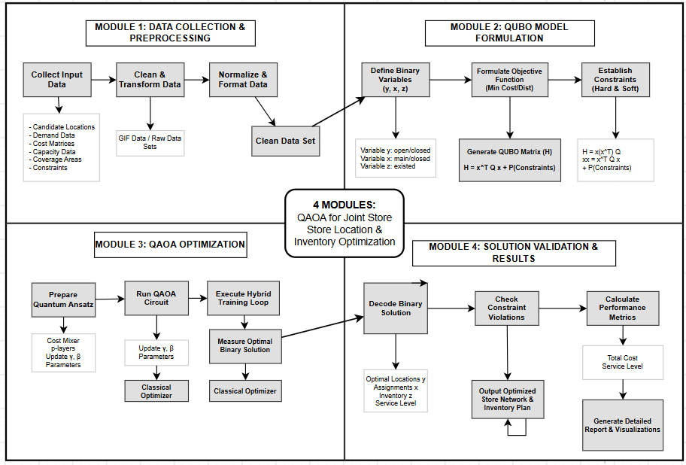
Fig. 1. Modular Workflow of the QAOA Framework for Joint Store Location and Inventory Optimization
In figure 1, the Module 1 takes candidate locations, demand data, cost matrices, capacity data and coverage areas, and cleans, normalizes and formats them into one data set. Module 2 defines the binary variables, writes the objective function, adds hard and soft constraints and produces the QUBO matrix. Module 3 prepares the quantum ansatz, runs the circuit, and repeats a hybrid training loop in which a classical optimizer updates the circuit parameters until the best binary solution is measured. Module 4 decodes the binary string into store locations, assignments and inventory choices, checks for constraint violations and calculates cost and service level, then produces the final network and inventory plan.
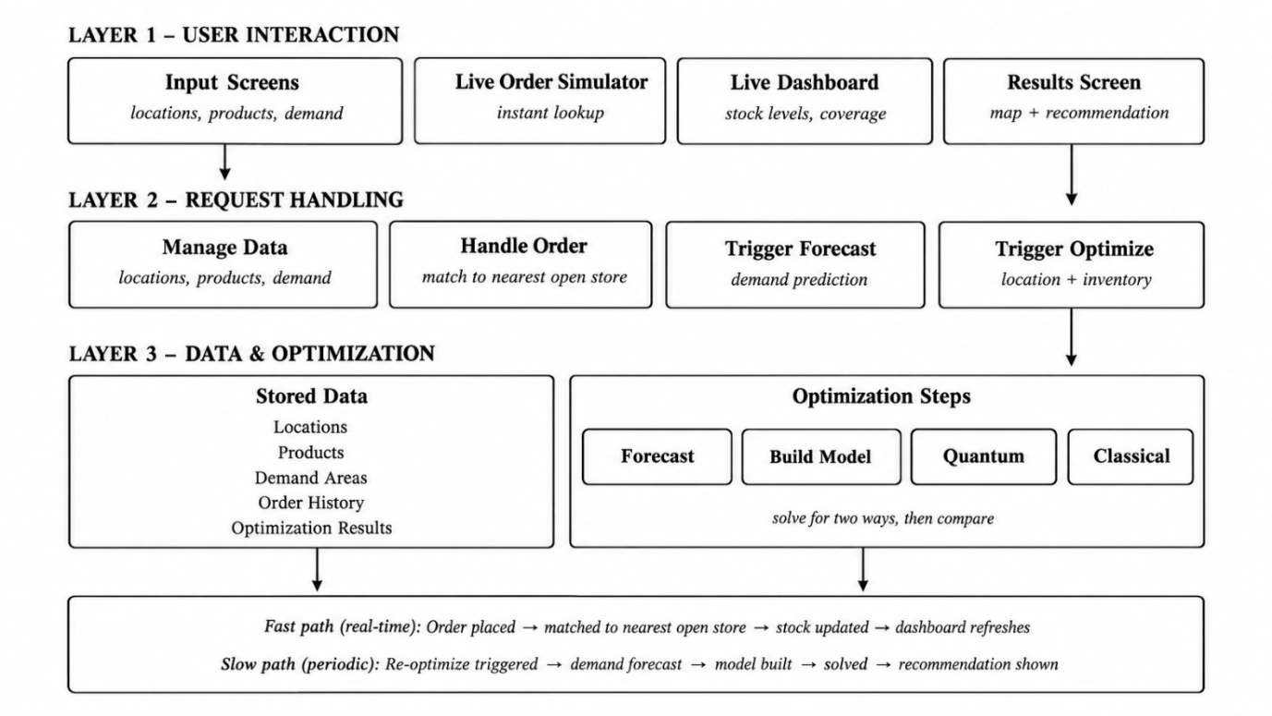
Fig. 2. Three-layer system architecture of the proposed platform
The architecture of the proposed system is presented in Figure. 2. The top level includes user interaction layers such as input screens, a live order simulator, a dashboard, and a results screen. The request handling layer is below the user interaction layer and is responsible for storing data, matching orders to the nearest available store, and executing forecasting or optimization. The lowest level is the data/optimization layer that stores product inventories, locations of demand areas, order history, and past results to facilitate the execution of the optimization process. The proposed system operates in two modes, namely, the fast and slow path. In the fast path, a request is made to place an order, which is matched to the nearest store with available inventory, followed by an update of the dashboard. By contrast, the slow path is initiated when a re-optimization request is made, including demand forecasting, model construction, and solving followed by presenting the results to the planner. The model can be solved using two approaches, quantum and classical, and the results can be compared.
  - Dataset
The experiments use five datasets, all built from open sources and covering Puducherry. They supply candidate store sites, demand zones, products, road travel times and demand. Together they replace the synthetic inputs, and each one maps to a model parameter used in this.
Table 3.1. Datasets Used in the Study
No. | Dataset | Source | Records | Role in the Model
1 | Store location | OpenStreetMap (Overpass API) | 48 candidate locations | Candidate sites j, opening cost f_j
2 | Demand zone | OpenStreetMap | 163 demand zones | Customer zones i
3 | Product | Blinkit public catalogue sample | Sampled SKUs | Products k, volume s_k, holding cost h_k
4 | Road network and travel time | OSRM on OpenStreetMap road geometry | 7,824 store-to-zone travel legs | Travel time t_ij
5 | Demand | Population-derived proxy | One value per zone and product | Demand D_i and d_ik
The datasets listed in Table 3.1 are used to formulate and evaluate the proposed QAOA-based dark-store optimization model. They provide geographical, product, transportation, and estimated demand information required for jointly optimizing store locations, customer assignments, and inventory allocation. These inputs are integrated into the QUBO formulation to determine a feasible solution while considering operational costs, storage capacity, budget, and delivery constraints.
3.3 Model Selection
The proposed system integrates store location selection, customer demand assignment, and inventory planning into a single optimization model. The problem is formulated using Quadratic Unconstrained Binary Optimization (QUBO) and solved using the Quantum Approximate Optimization Algorithm (QAOA). A classical Mixed-Integer Linear Programming (MILP) model implemented using PuLP and CBC is used as a baseline for evaluating the results.
Let J, I, and K represent the sets of candidate store locations, customer demand zones, and products, respectively. The model uses three binary decision variables. The variable yⱼ indicates whether store j is opened, xᵢⱼ represents whether demand zone i is assigned to store j, and zⱼₖ indicates whether product k is stocked at store j.
The objective is to minimize the total operational cost, including store-opening expenses, delivery costs, and inventory holding costs. The objective function is defined as follows:
Equation (1): Objective Function
$$\min{C}=\sum_{j∈J}{f_{j}y_{j}}+α\sum_{i∈I}{\sum_{j∈J}{D_{i}t_{ij}x_{ij}}}+β\sum_{j∈J}{\sum_{k∈K}{h_{k}z_{jk}}}$$
Here, fⱼ represents the cost of opening store j, Dᵢ denotes the demand of zone i, tᵢⱼ represents the road travel time between store j and demand zone i, and hₖ denotes the inventory holding cost of product k. The parameters α and β are used to adjust the relative contributions of delivery and inventory costs.
The model considers several operational constraints to ensure a feasible solution. Each demand zone must be assigned to exactly one store. Customer assignments and product stocking are permitted only at selected stores. The inventory must remain within the storage capacity of each store, and the total store-opening cost must not exceed the available budget. Product availability and maximum delivery-time limits are also considered during optimization.
Since QUBO requires an unconstrained binary objective function, the operational constraints are incorporated using penalty terms. Additional binary slack variables are introduced where necessary to represent unused budget and storage capacity. The resulting QUBO formulation is expressed as:
Equation (2): QUBO Objective
$\underset{\text{b}\text{∈\{0,1}{\text{\}}}^{\text{n}}}{\text{min}}{\text{H}}\text{(}\text{b}\text{)=}\text{C}\text{(}\text{b}\text{)+}\sum_{\text{r}\text{=1}}^{\text{m}}{{\text{P}}_{\text{r}}}\text{(}\text{b}\text{)}$
Here, b represents the binary decision and slack variables, C(b) denotes the operational cost, and Pᵣ(b) represents the penalty associated with violating a constraint.
The formulated QUBO model is converted into an Ising Hamiltonian and implemented using Qiskit. QAOA constructs a parameterized quantum circuit that alternates between cost and mixing operations. A classical optimizer adjusts the circuit parameters to search for a low-cost solution. The resulting binary outcomes are decoded to identify the selected store locations, customer assignments, and inventory decisions.
Finally, the obtained solution is validated against the operational constraints and compared with the classical baseline using objective value, demand coverage, feasibility, constraint violations, and execution time. This evaluation helps determine the effectiveness of the proposed approach for joint dark-store location and inventory optimization.

- Experimental Setup

This implementation has been entirely coded using Python programming language, except the front-end part of the planner which is done using JavaScript (React). Qiskit and Qiskit Aer packages have been used to build the QAOA circuit and to run simulations without any hardware noise. NumPy and SciPy packages have been used to formulate the QUBO matrix Q and the Ising coefficients and also to provide a classical optimizer to update the circuit parameters γ and β. Pandas package is used to clean and merge five Puducherry related datasets corresponding to sites, zones, SKUs, travel time and demand. The Requests package fetches the candidate sites and zones from the Overpass API and the road travel time data from the OSRM. The MILP baseline formulation has been defined and solved exactly using PuLP, while Matplotlib has been used to plot cost, feasibility and runtime graphs.
  - Evaluation Matrix
Table 4.1. Evaluation results of QAOA compared with the classical PuLP + CBC base line
Evaluation Metric | Value
QAOA Objective Value | ₹14,716.14
Classical (PuLP + CBC) Objective Value | ₹14,716.14
Optimal Gap | 0%
Demand Coverage | 100%
Constraint Violations | 0
Feasibility | Feasible
Storage Capacity Utilization | 73.9%
Budget Utilization | 85%
QAOA Circuit Depth (p) | 3
QAOA Runtime | 1.38 seconds

Table 4.1 compares the performance of QAOA with the classical PuLP + CBC solver for the tested prototype. Both methods achieved the same objective value, with a 0% optimal gap. The solution covered all demand zones without violating the defined constraints. Storage capacity and budget utilization remained within their respective limits. These results show that QAOA matched the classical solution for this experimental instance.
- Result and Discussion
QAOA-based dark store optimization model was evaluated through the comparison of results of the proposed method with classical PuLP + CBC optimization tool. In the verified prototype, both methods provided the same objective function value of ₹14,716.14, which implies an optimal gap of 0%. The model managed to satisfy the constraints fully and covered all demands, which means that the found solution is feasible.
Utilization of storage capacity amounted to 73.9%, and budget utilization was 85%, which means that the found solution is limited by available resources. The depth of QAOA circuit is, and the runtime of angle optimization is 1.38 seconds.
Such results prove that QAOA algorithm managed to provide the feasible solution, which coincided with the classical one for the examined instance. However, this fact does not mean that QAOA always outperforms classical methods. More research should be conducted in order to determine the efficiency of QAOA on larger problem instances and more runs.
- Conclusion
In this paper, we proposed an integrated dark-store planning model that determines simultaneously store location, customer-to-store assignment and product stocking, rather than doing it sequentially. The model was described using QUBO formulation, translated into an Hamiltonian and solved using QAOA and a classical mixed-integer linear programming model was implemented as the benchmark approach. For model implementation, publicly available data for Puducherry were used, including potential store locations and demand zones taken from OpenStreetMap, road travel time calculated from OSRM and a sample catalogue of Blinkit products. The model was integrated into a three-level platform architecture with the planner interface that allows visualizing the results on a map.
This work proved that all three sub-problems of dark-store planning can be formulated within one binary model and implemented on gate-based quantum circuit. Moreover, this work demonstrated that the penalty weight values and the depth of the circuit determine feasibility and optimal of QAOA solutions. The exact MILP solution remained faster and more robust at the size considered.
The framework is valuable due to the integration of the planner decisions into one single solution. It determines the optimal store locations, their customer zones and their product stock, with total cost and service level achieved. This will lead to reduced costs associated with store opening and inventory storage, shortened delivery routes and stock out minimization. Additionally, considering actual road travel times helps in making the results closer to real life city deliveries.
This paper contains several limitations: only small instances could be solved on the quantum computer simulator, which means that the whole set of 48 stores and 163 demand zones was solved only using the classical approach. The demand was estimated based on the population instead of real order data. The quantum circuits were simulated without any hardware noise effects and the number of qubits required grows rapidly with the increase of the number of demand zones and slack variables.
Future works include testing the proposed framework on quantum hardware and applying noise correction techniques, using more compact encoding with a lesser number of slack variables. We will also introduce real order data and its forecast and extend the model to multi-period problems. We will also consider introducing clustering to divide the whole city network into smaller clusters to fit on quantum devices.

- Reference
- Moncayo-Martínez, L. A., and He, N., “Quantum Optimization for Supply Chain: QUBO Formulations and QAOA Solutions for Facility Location and Load Balancing,” Results in Engineering, Vol. 29, 2026, Article 108373.
- Raj, A., Das, D., and Sawik, T., “Mitigating Disruption Impact in Q-Commerce Through Optimization of Dark Store Resilient Portfolio,” Transportation Research Part E: Logistics and Transportation Review, Vol. 205, 2026, Article 104518.
- Gomes, C., Fernandes, J. P., Falcão, G., Kar, S., and Tayur, S., “A Systematic Mapping Study on Quantum and Quantum-inspired Algorithms in Operations Research,” ACM Computing Surveys, Vol. 57, 2025, pp. 1–35.
- Agrawal, P., Balkanski, E., Gkatzelis, V., Ou, T., and Tan, X., “Learning-Augmented Mechanism Design: Leveraging Predictions for Facility Location,” Mathematics of Operations Research, Vol. 49, 2024, pp. 2626–2651.
- Fitzek, D., Ghandriz, T., Laine, L., Granath, M., and Kockum, A. F., “Applying Quantum Approximate Optimization to the Heterogeneous Vehicle Routing Problem,” Scientific Reports, Vol. 14, 2024, Article 25415.
- Pellow-Jarman, A., McFarthing, S., Sinayskiy, I., Park, D. K., Pillay, A., and Petruccione, F., “The Effect of Classical Optimizer and Ansatz Depth on QAOA Performance in Noisy Devices,” Scientific Reports, Vol. 14, 2024, Article 16011.
- Sanghi, N., Balodi, K. C., and Gupta, V., “The Emergence of the Indian Hyper local Grocery Delivery Industry: Dunzo v/s Blinkit,” Journal of Information Technology Teaching Cases, Vol. 14, 2024, pp. 119–128.
- Yang, X., Ostermeier, M., and Hübner, A., “Winning the Race to Customers with Micro-Fulfillment Centers: An Approach for Network Planning in Quick Commerce,” Central European Journal of Operations Research, Vol. 32, 2024, pp. 295–334.
- Amin-Tahmasbi, H., Sadafi, S., Ekren, B. Y., and Kumar, V., “A Multi-Objective In- tegrated Optimisation Model for Facility Location and Order Allocation Problem in a Two-Level Supply Chain Network,” Annals of Operations Research, Vol. 324, 2023, pp. 993–1022.
- Azad, U., Behera, B. K., Ahmed, E. A., Panigrahi, P. K., and Farouk, A., “Solving Vehicle Routing Problem Using Quantum Approximate Optimization Algorithm,” IEEE Transactions on Intelligent Transportation Systems, Vol. 24, 2023, pp. 7564–7573.
- Daduna, H., “On Queueing-Inventory-Location Problems,” Annals of Operations Research, Vol. 331, 2023, pp. 679–710.
- Lee, T., Han, S. R., and Song, B. D., “Optimization of OmniChannel Distribution Network Using Micro Fulfillment Center Under Demand Uncertainty,” IEEE Access, Vol. 11, 2023, pp. 107496–107510.
- Tordecilla, R. D., Montoya-Torres, J. R., Quintero-Araujo, C. L., Panadero, J., and Juan, A. A., “The Location Routing Problem with Facility Sizing Decisions,” International Transactions in Operational Research, Vol. 30, 2023, pp. 915–945.
- Çelik, M., Archetti, C., and Süral, H., “Inventory Routing in a Warehouse: The Storage Replenishment Routing Problem,” European Journal of Operational Research, Vol. 301, 2022, pp. 1117–1132.
- Chen, X.-Y., Yang, J.-B., and Xu, D.-L., “Inventory Policy and Heuristic for Long-Term Multi-Product Perishable Inventory Routing Problem with Static Demand,” Journal of the Operations Research Society of China, Vol. 10, 2022, pp. 659–683.

